**Apsara – For good handwriting**

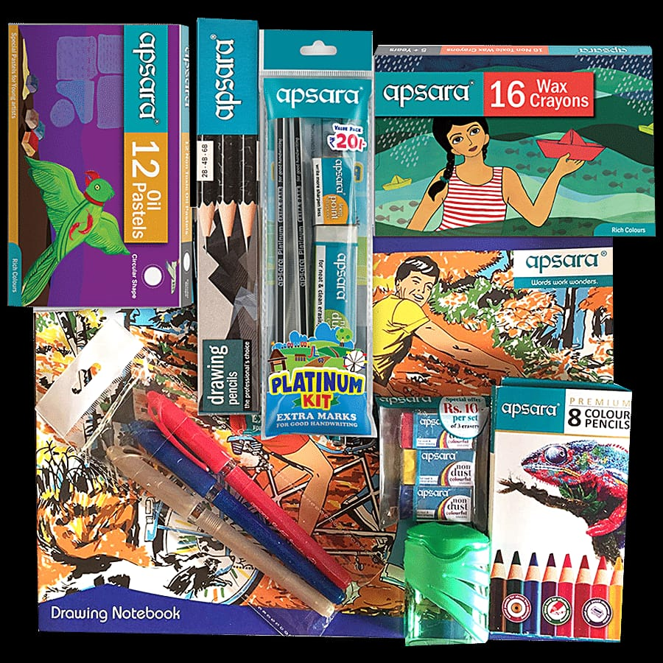

Apsara Absolute Extra Dark Pencil is made from well-treated and high-quality wood and leads to making them soft, long-lasting and easy to sharpen. Its super dark lead needs less pressure when writing and stays dark for a long time. Hindustan Pencils Pvt. Ltd. is an Indian manufacturer of pencils, writing materials and other stationery items, established in 1958 in Bombay.

The link of the reel-https://www.facebook.com/reel/830714868784602